Module 2 Week 3 Lab 3.2 and Lab 3.4
02/08/2026
Danny LeBlond
CNG4054X00 Malware Threats and Analysis

Lab 3-2
Analyze the malware found in the file Lab03-02.dll using basic dynamic analy sis tools. Questions
- How can you get this malware to install itself?
The malware installs itself by being loaded as a DLL by another Windows program. A DLL cannot run by itself pretty much just tools so it has to be loaded into memory by an .exe (executable) for it to work.
- How would you get this malware to run after installation?
The malware can be made to run again by configuring Windows startup settings so that a legitimate process loads the malicious DLL automatically when the computer is turned on.
- How can you find the process under which this malware is running?
You can find the process the malware is running under by using Process Explorer. By searching for the DLL name, Process Explorer shows which Windows process loaded the DLL and is running it. (I wasn’t running anything yet, just answering the question.)
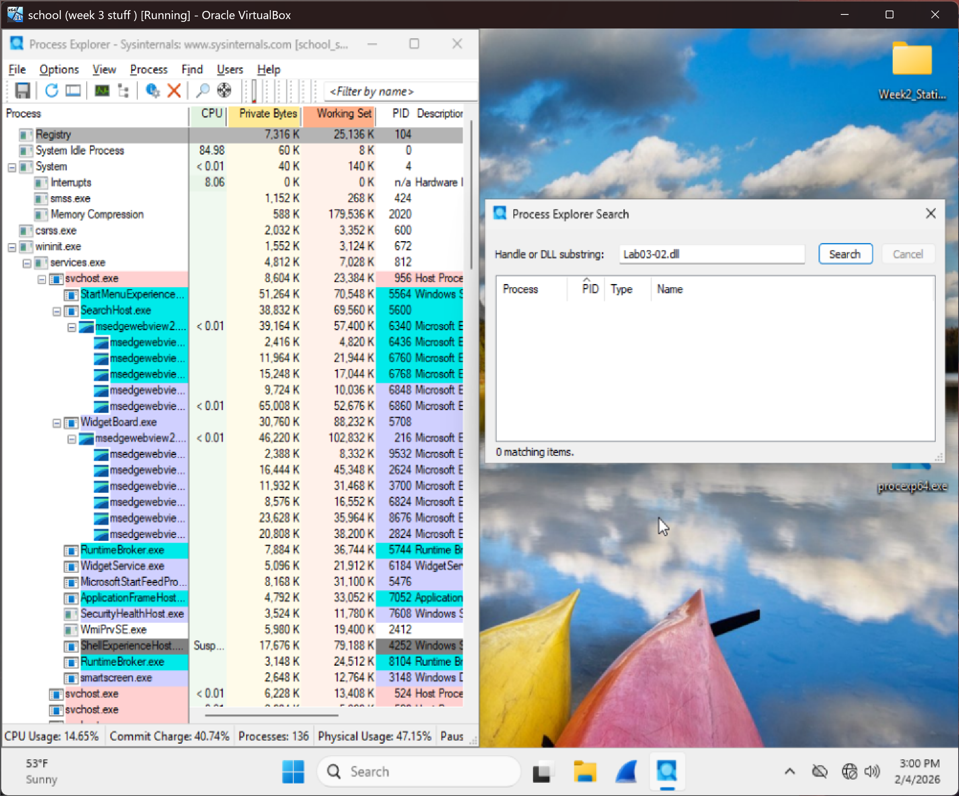
- Which filters could you set in order to use procmon to clean information?
I found that the malware DLL can be loaded using regsvr32.exe. When I ran the DLL with regsvr32 using the command line, Windows showed an error message saying the module was loaded but the DllRegisterServer entry point was not found. That proves that regsvr32 was able to load the DLL into memory even though registration failed. Because regsvr32 is used by Windows to load DLL files it can also be used by malware to run its code. During testing I also checked the executables Lab03-01.exe through Lab03-04.exe using Process Monitor with a filter searching for Lab03-02.dll. I didn’t see any anything showing those programs loading the DLL. Maybe I messed something up but because I did not see the DLL being loaded by those files that’s when I tested loading the DLL directly using the command line with regsvr32.
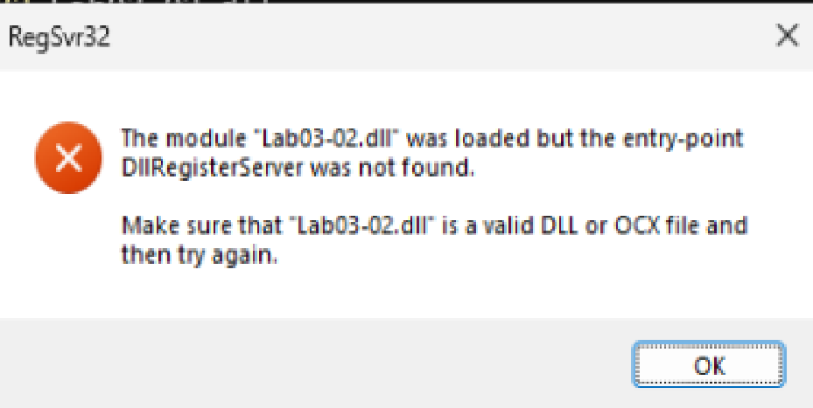
5. What are the malware’s host-based indicators?
I did not see any clear suspicious registry keys or file activity related to the malware. I look at stuff using Process Monitor with filters for regsvr32.exe and Lab03-02.dll, but no events appeared showing the DLL creating files or changing the registry.
I also used Regshot to compare registry snapshots before and after testing. When I searched the results for “Lab03-02” and “regsvr32,” I did not find any registry changes connected to the malware. Most results looked like normal Windows system entries stuff.

6. Are there any useful network-based signatures for this malware?
I watched the malware to see if it tried to connect to the internet while running the DLL using regsvr32. I used Process Monitor and checked for things like TCP connections, UDP traffic, sending or receiving data, and connections to IP addresses or websites. I did not see any network communication during testing. So I dont think there were any useful network based signatures found.

Lab 3-4
Analyze the malware found in the file Lab03-04.exe using basic dynamic analy sis tools. (This program is analyzed further in the Chapter 9 labs.) Questions
1. What happens when you run this file?
When I ran the program a command window quickly opened and closed. After that the file deleted itself from the folder thats what happened with out tools. Using Process Monitor I saw the program loading system DLL files, accessing registry keys, it was doing a lot of stuff. I also saw file deletion activity marked as Delete: True performed by svchost.exe which may be cleanup behavior after the file ran or could be normal windows stuff not sure but its there. The program runs very quickly, then exits and thats pretty much it.
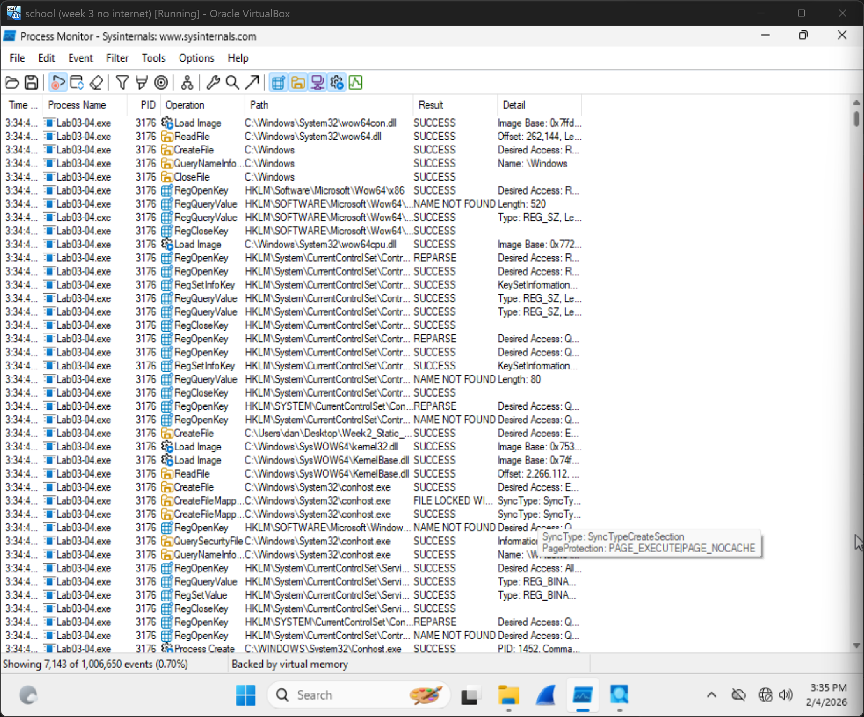
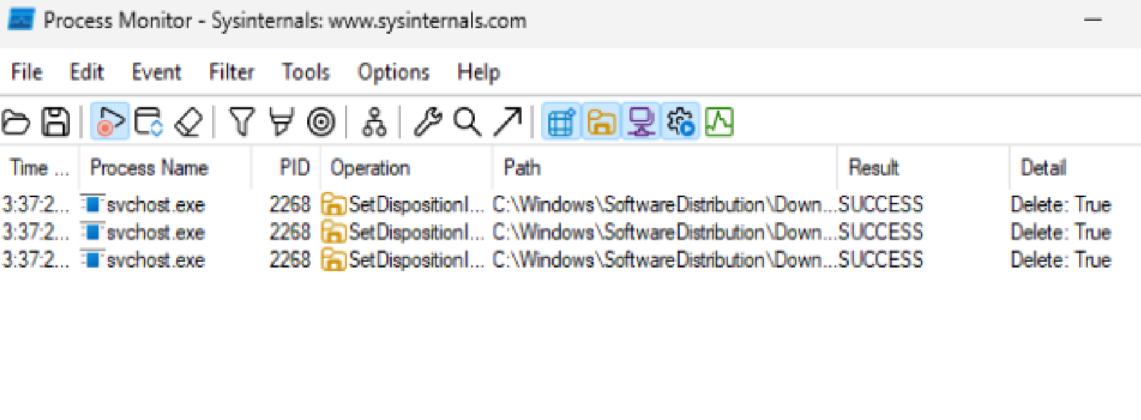

2. What is causing the roadblock in dynamic analysis?
The roadblock in dynamic analysis is that the malware runs really fast and deletes itself after its ran. Because the program removes itself and stops running almost immediately, it is difficult to capture behavior or analyze the program while it is actually going. The possible deletion being performed by another system process also makes stuff more difficult.

3. Are there other ways to run this program?
Yes there are other ways to run this program. The way I kind of just went to do it first with the tools up the malware could be run while Process Monitor and Process Explorer are already recording activity before it runs and after you just look at those two tools. Another way is to make a backup copy of the file before running it so the original isnt lost if it deletes itself. Then just look over the copy.

